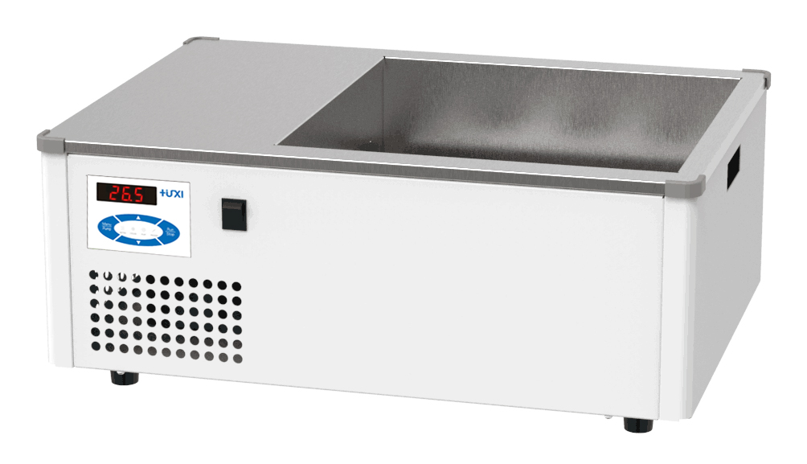

HLG-24 Heating and cooling water bath

1、Application

HLG Series Heating and cooling thermostatic water bath with the function of heating and cooling, built-in circulating pump for internal circulation of the liquid in the tank, so the uniformity is high, up to ± 0.1 ℃, widely used in medical and health care, colleges and universities, scientific research units and industrial and mining enterprises, etc. to do evaporation, drying, concentration, thermostatic heating of chemical, serological examination, thermostatic cultivation of biological products, sterilization and boiling.

2、Features

- LED display, waterproof and oil-proof operation panel, four-heat design, heating, cooling, cycle indicator display
- Large opening for more samples for thermoregulation.
- Heating and cooling function, heating and cooling are integrated in one unit
- High-quality stainless steel in contact with liquids.
- With internal circulation function, good temperature uniformity, internal circulation can be controlled
- Standard with sample holder, height 50mm.
- High-temperature alarm and dry-burn protection

- Technical Parameters
Model | HLG-24
Item No. | 1037007001
Temperature range (℃) | -5~100
Temperature stability (℃) | ±0.05
Temperature uniformity (℃) | ±0.02
Cooling power（w） | 750(20℃)
Heating power (w) | 2000
Pump flow rate (L/min) | 12
Pump pressure(bar) | 0.8
Alarm function | YES
Bath volume( L) | 24
Bath size (mm) | 400*400*150
Overall dimensions (mm) | 640*440*355
Packing size (mm) | 800*590*355
Net weight (kg) | 44
Gross weight(kg) | 45

- Packing List
No | Name | Qty
1 | Water bath | 1pcs
2 | Support | 1pcs
3 | Bath cover | 1pcs
4 | Manual | 1set

